FROM TCU: 102 miles
- Go West on I30 and continue West at the I30 and I20 Merger
- Exit 406, follow signs for South Bowie Dr / Old Dennis Rd and head North
- Head West on 180 to Mineral Wells
- Head North/NorthWest on 337 to Graford, Graham, Possum Kingdom
- Stay North on 337 as it crosses 254, don’t get fooled by Possum Kingdom Lake sign.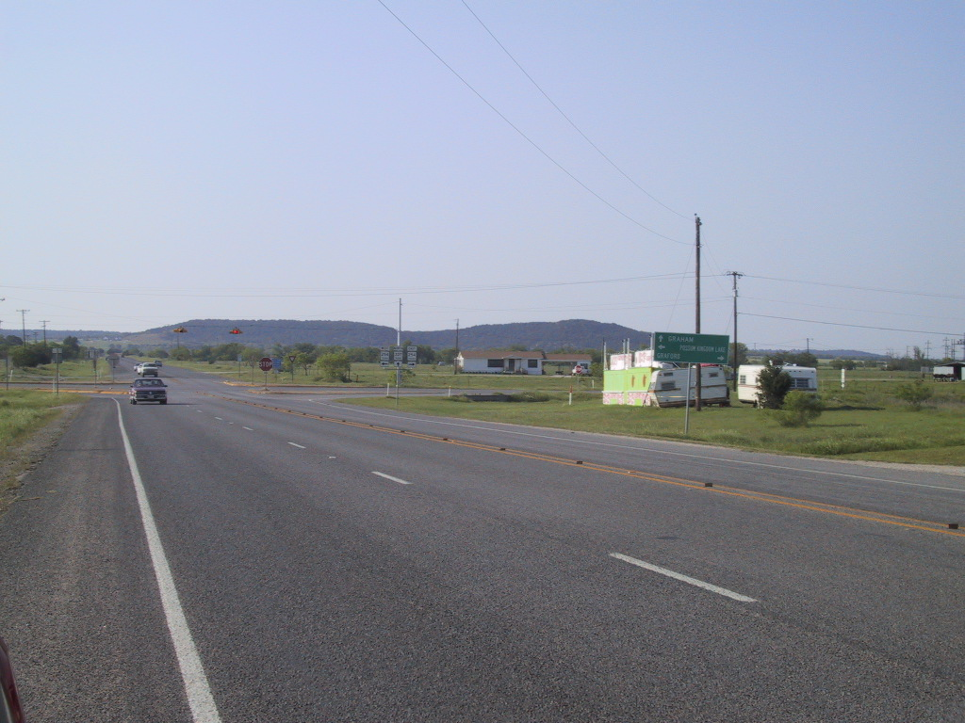

- Stay North as 337 merges into 16
- Just before you reach Graham, make almost a U-turn to head South on FM1287
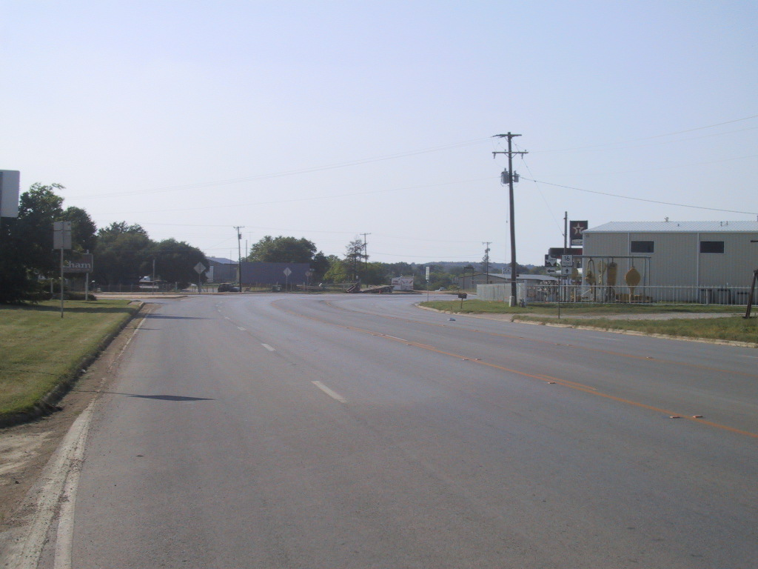

- Head East on FM1148
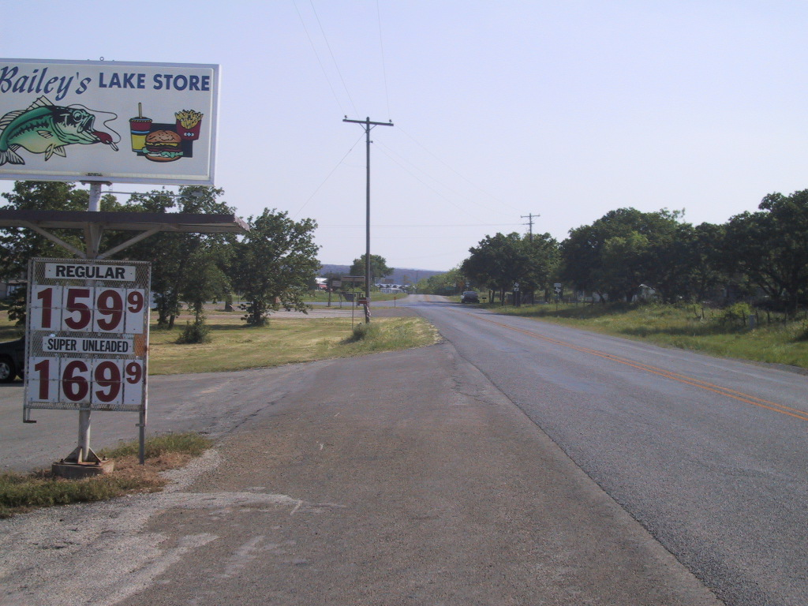

Head South on Fox Hollow Rd (Look for big Fox Hollow Sign)
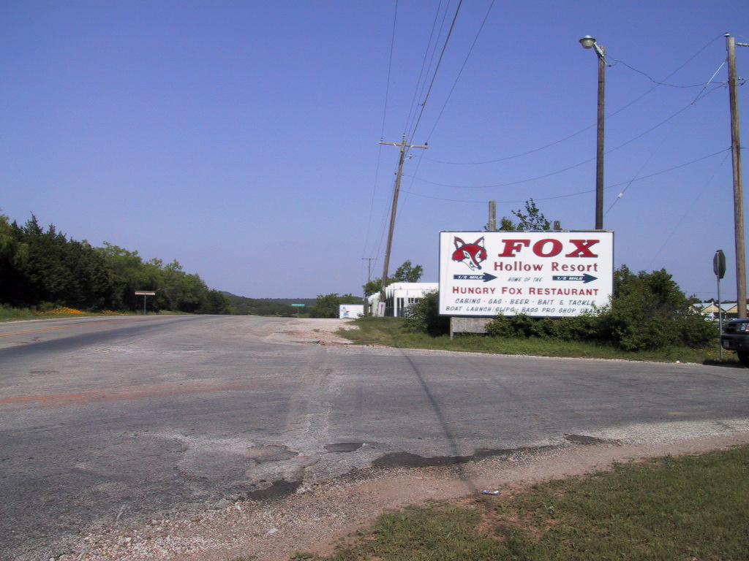

Merge onto Simmons Ln

We are the last houses on Simmons Lane (4747 Simmons Ln, Graham, TX 76450)
http://binged.it/Pbrnkh

