Worksheet (Simple Harmonic Motion) Using Phet Interactive Simulation

Dept. Of Physics and Astronomy Texas Christian University

Name:

Instructions courtesy of: Nawal Nayfeh, University of Sharjah

This activity consists of two parts.
Part one: Simple Pendulum.
Part two: Mass on a spring.

To be familiar with simple harmonic motion, periodic time of an oscillation, angular velocity, the parameters that affect the oscillatory motion (length of the pendulum, the mass on a spring, the angle with the equilibrium position for simple pendulum and the distance from equilibrium position for mass on a spring) using Phet simulation, kindly, open the following links and play with them.

For Simple Pendulum follow the link below.
https://phet.colorado.edu/sims/html/pendulum-lab/latest/pendulum-lab_en.html
For Mass on a Spring follow the link below.
https://phet.colorado.edu/sims/html/masses-and-springs/latest/masses-and-springs_en.html

Part I
Simple Harmonic Motion
(Simple Pendulum)
Objectives:
In this experiment the student can observe and study the periodic motion in a plane and investigate the relation between the period of a simple pendulum and its length. Also, the student can determine the acceleration due to gravity by this experiment.
Theory:
An ideal pendulum is a point mass (m) suspended at one end of a massless string with the other end of the string fixed as shown in Fig. 1.
mgcosθ
mgsinθ
mg
θ
l
The motion of the system takes place in a vertical plane when the mass (m) is released from an initial angle θ. The angular amplitude θ is defined by the angle which the string makes with the vertical.
The weight of the pendulum acts downward, and it can be resolved into two components. The component (mgcosθ) is equal in magnitude to the tension in the string. The other component acts tangent to the arc along which the mass (m) moves. This component provides the force which drives the system. In equation form; the force (F) along the direction of motion is:
Fig. 1
F = - mg sinθ …………………(1)

For small values of the initial angle θ, the approximation Sinθ = tanθ = x/l, can be used in equation 1, and then becomes

$F=-\frac{\text{m g x}}{l}$ .…………………(2)

so, we can write according to Newton’s second law:

$\text{ m }\frac{d^{2}x}{\text{d}{\text{t}}^{2}}=-\frac{\text{m gx}}{l } ⇒ \frac{d^{2}x}{\text{d}{\text{t}}^{2}}+\frac{g}{l}$ ………...……(3)

The vibration of a pendulum describes the simple harmonic motion (S.H.M.), the period (T) is given by

$T=\text{2 }π \sqrt{\frac{l}{g}} ⇒ {\text{T}}^{2}=\frac{4 π^{2}}{g}l$………...……(4)

Where T: is the periodic time
l: is the length from the point of suspension to the center of the bob.
g: acceleration of gravity.

To satisfy the objective of this experiment, follow the link below and do the following steps.
https://phet.colorado.edu/sims/html/pendulum-lab/latest/pendulum-lab_en.html

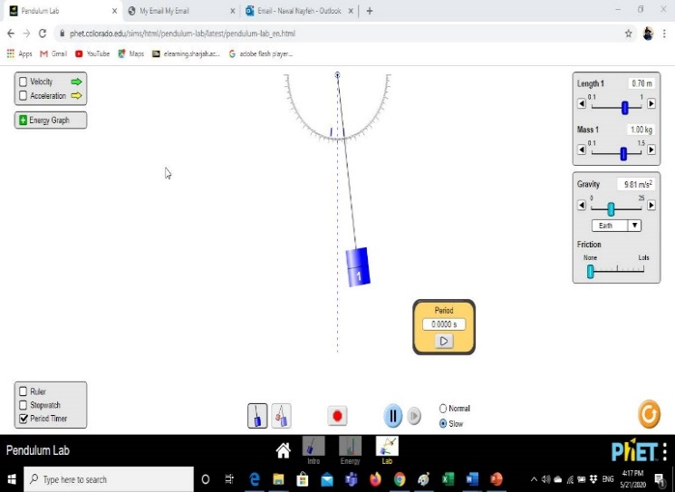
- Click on lab screen and use the length controller to control the length of the pendulum (l), set l =1m. Record the length in table 1.
Length and mas
controllers
- Control the angle (click on the mass and drag along the protractor to fix the angel), the angle must be very small (<10). (θ=8º) and click on slow mode of the simulation.
- Click on period timer (on the lower left corner of the lab screen) to measure the periodic time of one full oscillation (T). Record the periodic time in table.
- Repeat the previous steps for different lengths of (l) as shown in the table 1. Record your data
Data Analysis:
- Calculate the square of the periodic time (T²).
- Use Excel sofware to plot a graph of T² versus l, T² as the ordinate and l as the abscissa.
- Use the equation of the graph to determine its slope, use the slope of the line to calculate the acceleration due to gravity g which is given by:

Table 1
L (m) | T(s) | T² (s²)
1.0
0.9
0.8
0.7
0.6
0.5
0.4
0.3
0.2
0.1

- Consider the known value for g = 9.81 m/s² calculate the percentage error in g.
$$slope=\text{ , }{\text{g}}_{\text{exp}} = \\ δ\text{g\%}=$$

Questions:
- What requirement must a force acting on a object satisfy in order for the object to undergo simple harmonic motion?
……………………………………………………………………….
………………………………………………………………………..
- Define the periodic time of oscillation. It depends on what?
……………………………………………………………………….………………………………

……………………………………………………………………...………………………………..
Part II
Simple Harmonic Motion
(Mass on a Spring)
Objectives:
In this experiment, the student can observe and study the periodic motion in a plane and investigate the relation between the periodic time of a mass on a spring and the hanged mass. The student can determine the spring constant of the spring using the experimental data of this experiment.
Theory:
A common example of an object oscillating back and forth under the effect of a restoring force that is directly proportional to the displacement from equilibrium (Hooke’s Law) is the case of a mass on the end of an ideal spring.
Hooke’s Law
Is the name that was given to this relationship between force and displacement of a mass undergoes an oscillatory motion.
F = - kX ………...……(5)
Here, F is the restoring force, x is the displacement from equilibrium, and k is the spring constant. Remember that the minus sign indicates the restoring force is in the direction opposite to the displacement.
Mass on a Spring
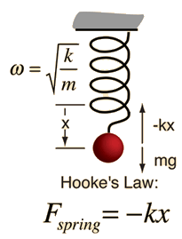
The motion of a mass on a spring can be described as Simple Harmonic Motion (SHM) as shown in Fig 2, where the net force can be described by Hooke’s law. We can now determine how to calculate the periodic time and frequency of an oscillating mass (m).
Fig. 2
Newton's second law gives the equation of motion:
$mg-kx=ma=m\frac{d^{2}x}{{dt}^{2}}$ ………...……(6)
The solution of this equation is:
$x=Asin(ωt)$ ………...……(7)
Where, ω is the angular velocity of the oscillatory motion and is given by:
$ω=\sqrt{\frac{k}{m}}$ ………...……(8)
Then the periodic time of oscillation is given by T=2π/ω
then, $T=2π\sqrt{\frac{m}{k}}$………...……(9)
Where T: is the periodic time, m: is the mass hanged on the spring and
k: is the spring constant.

To satisfy the objectives of this experiment, follow the link below and do the following steps.

https://phet.colorado.edu/sims/html/masses-and-springs/latest/masses-and-springs_en.html

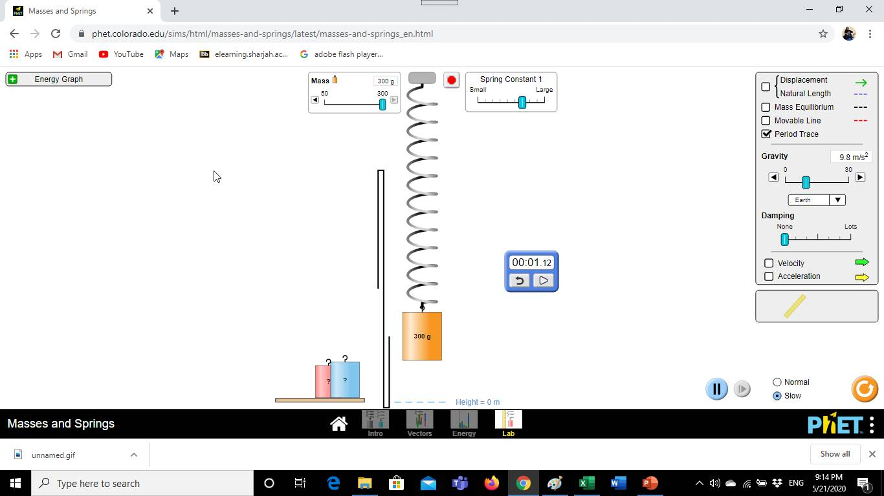
- Click on lab screen and use the mass controller to control the mass hanged to the spring (m), set m =150kg. Record the mass in table 2.
Spring constant controller
mass controller
Time meter
- Control the spring constant using the spring constant controller and set it at the large value.
- Click on time meter and drag it near the spring. Put √ on period trace selection to trace the line of full cycle.
- Compress the spring to the maximum compression, Set the simulation speed at slow mode.
- Press on start Potton, watch the trace of full cycle, then press the arrowhead on timer meter to start measuring the periodic time (T). Record the periodic time in table 2.
- Repeat the previous steps for different masses of (m) as shown in the table 2. Record your data in the table 2.

Data Analysis:
- Calculate the square of the periodic time (T²).
- Use Excel sofware to plot a graph of T² versus m, T² as the ordinate and m as the abscissa.
- Use the equation of the graph to determine its slope, use the slope of the line to calculate the acceleration due to gravity g which is given by:

$k=\frac{4 π^{2}}{\text{slope}}$ Table 2
m (kg) | T(s) | T² (s²)
50
100
140
180
220
260
300

Questions:
- Explain what will happen to the periodic time? if you change the spring constant to the low value.

…………………………………………………………………

…………………………………………………………………

Explain theoretically how can you determine the spring constant using hooks law?
……………………………………………………………………………………………………..

……………………………………………………………………...………………………………

…………………………………...…………………………………………………………………

…………………………………………………………………………..…………………………

