**Lab 4 – Vector Addition of Mechanical Forces**

**Department of Physics and Astronomy**

**Texas Christian University**

**Name : Section & TA:**

Courtesy of University of Colorado Boulder. This lab uses the **Vector-Addition** simulation from PhET Interactive Simulations at University of Colorado Boulder, <https://phet.colorado.edu/sims/html/vector-addition/latest/vector-addition_en.html>

This activity consists of two Parts

Part one : Two forces acting on a ring using force table.

Part two: Three forces acting on a ring using force table.

To be familiar with vectors, magnitude, direction and vectors components, vectors addition by graphical and analytical methods using Phet simulation kindly, open the following link and play with it.

### <https://phet.colorado.edu/sims/html/vector-addition/latest/vector-addition_en.html>

**Objectives:**

In this experiment you should learn the definition of a vector, and how to represent it in space. Also, you should learn how to apply the rules for vector addition both graphically and analytically.

**Apparatus:**

Force table with three to four pulleys, mass hangers, slotted masses, string, protractor, ruler, and sheets of graphic papers.

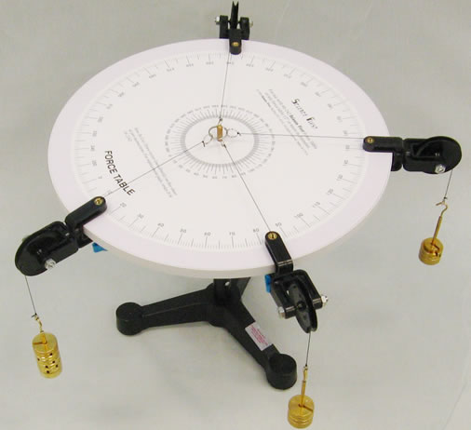

The resultant force (FR) of two Forces as an example F1 & F2 can be found by two methods analytical or graphical method.

In the analytical method each vector (Force) such as (F) which makes an angle (θ) with horizontal x- axis is first resolved into two components. Those components are horizontal or x- component (Fx) and vertical or y- component (Fy ). Those components are given by :



**F**

**Fx**

**Fy**

**Fx = F cos , Fy = F sin**

Consider the case of three vectors (Forces) F1 , F2 , F3 ,

FRx = F1x + F2x + F3x  & FRy = F1y + F2y + F3y

The magnitude of the resultant vector (FR) is found to be the following because the components Rx and Ry are at right angles:



and the angle (  ) that the

resultant makes with x- axis is given by :

In the graphical addition process. The resultant vector is the vector drawn from the tail of the first vector to the head of the last vector

**C**



**R**

**B**

**A**

The polygon method is illustrated for the case of three vectors as follows:

**C**

**A**



**B**

To verify the objectives experimentaly we will use phet similation software and we will act on an object by two forces and then three forces, then we will find their resultand by finding practicaly the eequilibrit force (FE). So, the FE is the equilibrant force that must be applied in order to keep an object in equilibrium. The magnitude and direction of this FE can be found by trial and error experimentally. The resultant force FR can be found from knowledge that FR and FE have the same magnitude but opposite directions.

***Part one: Two forces acting on a ring using force table.***

*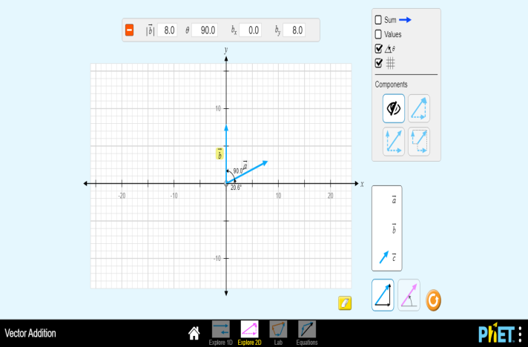Use F1 as vecrors a and F2 as vector b on phet simulation.*

**Procedure** :

**1- Resultant of two vectors**

1. Fix the first vector (F1) on about 20o angle and fix it is magnitude about 10N. *(vector a)*
2. The second vector ( F2) , fix it about 90o angle and control it is value to be almost 8N. *(vector b)*
3. 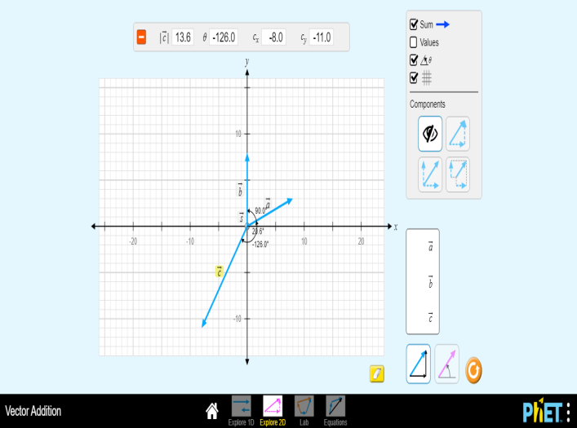Find the force that is nedded to balance the above two forces (vectors). This force is known as FE. *(vector c)*

**FE=……… θE=………**

1. Find the resultant force FR ( magnitude and direction )

**FR=……… θR=………**

***Part two: Three forces acting on a ring using force table.***

**2- Resultant of three vectors :**

1. With the first vector (F1), fixed on approximetly 300. and it is magnitude is 6N. *(vector a)*
2. The second vector ( F2), fix it about 100o angle and control it is value as 8 N. *(vector b)*
3. The second vector ( F2) , fix it about 145o angle and control it is value as 11 N. *(vector c)*
4. Find the resultant force of these three forces using Phet simulation FR.

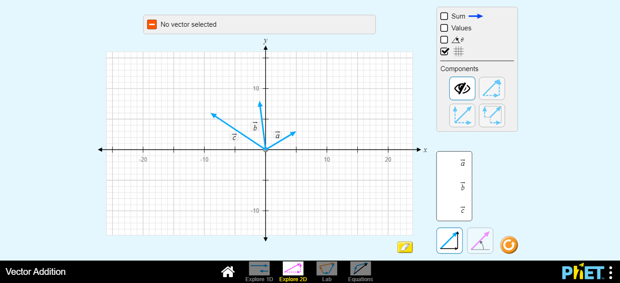**FR=………**

**θR=………**

1. Write down the value of FE and it is direction.

**FE=………**

**θE=………**

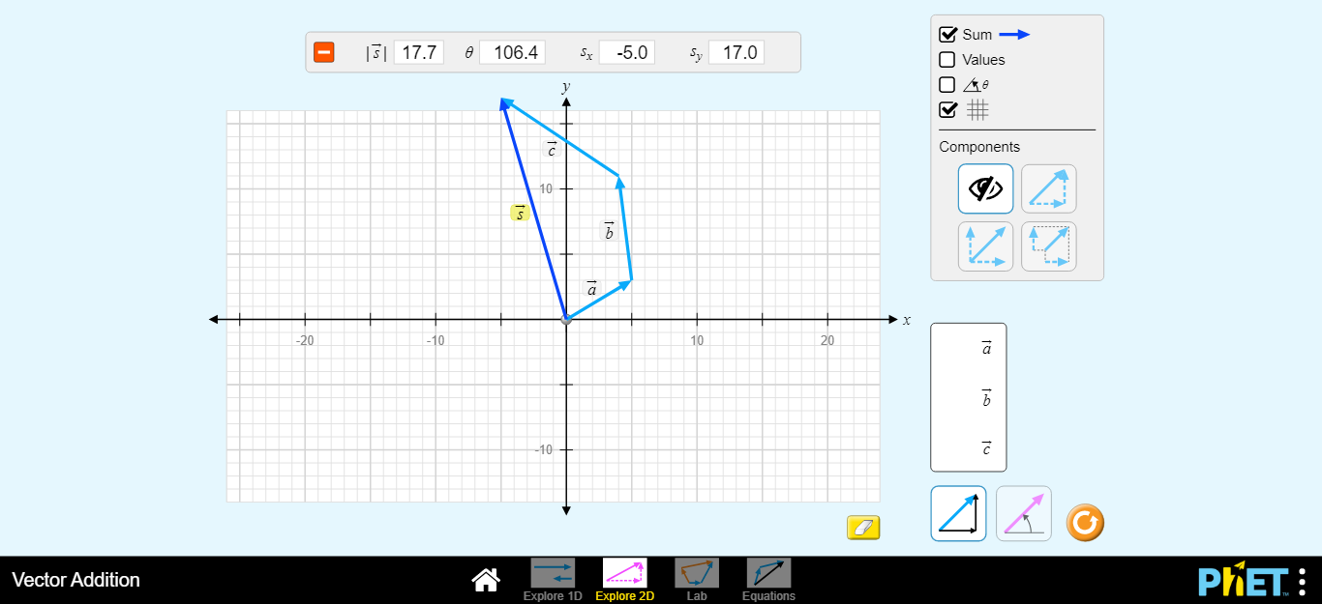

#### Da ta Analysis :

1) For part 1, use Phet simulation for each vector to display the vector’s components and then fill

**F1x, F2x, F1y, F2y, FEx, FEy, |FR|, and the angle θ where the equilibrant force makes with positive the x-axis in table 1.**

1. **Calculate the percentage error of the magnitude of the experimental value of FR compared to analytical solution for FR.**

**…………………………………………………………………………………………..**

**…………………………………………………………………………………………..**

**…………………………………………………………………………………………..**

1. **Using phet simulation, Find the resultant force (FR ) of the two vectors** a **and** *b* **graphically. (attach a screen shot of the graphical method)**

**FR=……… θR=……… (Graphically)**

1. **Calculate the percentage error of the magnitude of the graphical solution for FR compared to analytical solution for FR**

**…………………………………………………………………………………………..**

**…………………………………………………………………………………………..**

**…………………………………………………………………………………………..**

Table 1

Analytical solution

|  |  |  |  |  |
| --- | --- | --- | --- | --- |
| **Force** | **Force ( N )** | **Direction** | **x-component** | **y-component** |
| **F1** |  | **20o** |  |  |
| **F2** |  | **90o** |  |  |
| **FR** |  |  |  |  |

**FR=……… θR=………(analytically)**

2) For part 2, use Phet simulation for each vector to display the vector’s components and then fill

**F1x, F2x, F1y, F2y, F3x, F3y FEx, FEy, |FR|, and the angle θ where the equilibrant force makes with positive the x-axis in table 2.**

1. **Calculate the percentage error of the magnitude of the experimental value of FR compared to analytical solution for FR.**

**…………………………………………………………………………………………..**

**…………………………………………………………………………………………..**

**…………………………………………………………………………………………..**

**…………………………………………………………………………………………..**

1. **Using phet simulation, Find the resultant force (FR) of the three vectors** a, *b* **and** *c* **graphically. (attach a screen shot of the graphical method)**

**FR=……… θR=……… (Graphically)**

1. **Calculate the percentage error of the magnitude of the graphical solution for FR compared to analytical solution for FR**

**…………………………………………………………………………………………..**

**…………………………………………………………………………………………..**

**…………………………………………………………………………………………..**

**…………………………………………………………………………………………..**

##### Table 2

**Analytical solution**

|  |  |  |  |  |
| --- | --- | --- | --- | --- |
| **Force** | **Force ( N )** | **Direction** | **x-component** | **y-component** |
| **F1** |  | **30o** |  |  |
| **F2** |  | **100o** |  |  |
| **F3** |  | **145o** |  |  |
| **FR** |  |  |  |  |

**FR=……… θR=………(analytically)**

**Questions :**

1. What is the difference between vector and scalar quantity?
2. Classify each of the following physical quantities as vectors or scalars:

a) Volume : b ) Force : c ) density :

d ) velocity e ) distance f ) acceleration

g ) mass h ) speed i) weight

1. What are the conditions of equilibrium for given forces?
2. What are the conditions for the two vectors to be equal?
3. Two forces, one of 2 N and the other of magnitude 3 N are applied to the ring of a force table. The direction of both forces is unknown. Which best describes the limitations on, the magnitude of the resultant force

