Lab 9 – Fluid Forces
Department of Physics and Astronomy
Texas Christian University

Name : Section & TA:

Courtesy of University of Colorado Boulder. This lab uses the Fluid-pressure-flow simulation from PhET Interactive Simulations at University of Colorado Boulder, http://phet.colorado.edu/en/simulation/fluid-pressure-and-flow
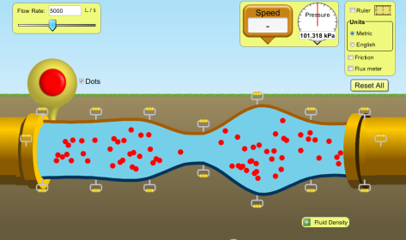
Objectives:
Apply the concept of static fluid pressure to real world problems
Investigate concepts of fluid flow

Head to the following website to investigate fluid pressure. Click ‘Run Now!’
http://phet.colorado.edu/en/simulation/fluid-pressure-and-flow

Notes :
- Use Pascals for your unit of pressure. Remember, $[Pa]=[\frac{N}{m^{2}}]$
- For all of your pressures today, use four significant figures for your answers. For example, if the pressure meter gives you 101.325 kPa you can write that as 101,300 Pa.

Questions:

Part 1: Atmospheric Pressure
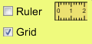
Setup
- In the top right hand corner, select the grid option for the simulation.
- Using the sliding knob, fill the pool so that there the water is 3 meters deep
- Make sure that the acceleration due to gravity is equal to 9.8 m/s²

- Click the pressure meter to control it. Drag the pressure meter to ground level and determine the pressure at the ground. Record this value in the space below.

P_{atm} = __________________ Pa

This value is the atmospheric pressure; because that is the pressure you feel when one atmosphere is on top of you.

- Where do you think the atmospheric pressure is the least?

Denver, CO (1609 m above sea level) Ocean City, NJ (0 meters above sea level)
Death Valley, CA (86 meters below sea level) Hillsborough, NJ (45 meters above sea level)

Explain your response: _______________________________________________________________________
__________________________________________________________________________________________
__________________________________________________________________________________________
__________________________________________________________________________________________

Part II: Gauge pressure, Absolute Pressure, and atms

- Now let’s go under water, where the pressure is different. The pressure-meter on the simulation measures absolute pressure, the actual pressure that is occurring. Depending on our situation it may be beneficial to represent the pressure in a different way. Gauge pressure ignores atmospheric pressure and only takes into account the fluid. Atmospheres or atms represent the “number of atmospheres” you are experiencing. Use the simulation and your brain to fill in the table below.

 | Gauge Pressure | Absolute Pressure | Atmospheres
1.0 meter below the surface
2.0 meters below the surface
3.0 meters below the surface

Part III: Calculating Pressure

- To determine the absolute pressure of a static (unmoving) fluid, we can apply the following concept.

$$P= P_{0}+ ρgh$$

Summarize this formula in words. ______________________________________________________________
____________________________________________________________________________________________________________________________________________________________________________________

- For this next part you’ll have to decide what type of person you are. Do you want to jump into a pool full of honey or gasoline?
Gasoline (ρ_{g} = 700 kg/m³) Honey (ρ_{H} = 1420 kg/m³)

Justify your response: ________________________________________________________________________
__________________________________________________________________________________________
__________________________________________________________________________________________

- So now that you’ve made your decision, predict the gauge pressure 3.0 meters below the surface of your fluid. Show your work in the space below.

Check your answer by using the simulation.
Part IV: Pressure at different depths

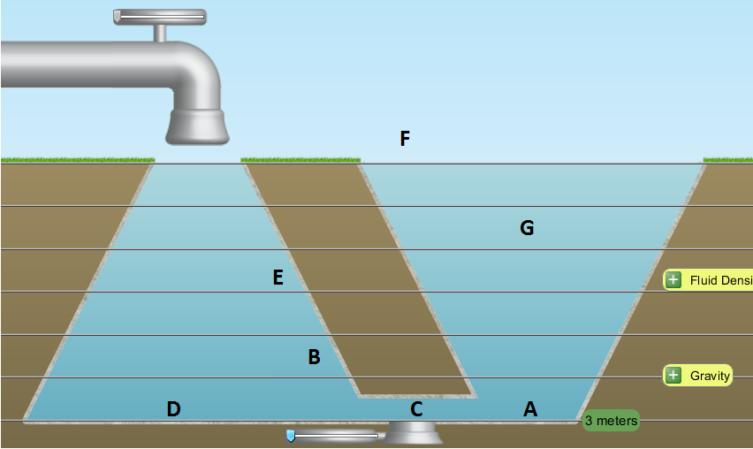

- Rank the following points on the diagram above from least pressure to greatest pressure. If any points have the same pressure, give them the same ranking.

____ A ____ B ____ C ____ D ____ E ____ F ____ G

Justify your response: ________________________________________________________________________
__________________________________________________________________________________________
____________________________________________________________________________________________________________________________________________________________________________________

Part V: Fluid Flow

Setup
- Click on the ‘Flow’ Tab

- We are now going to talk about fluids moving. Begin by record the current time in the space below.
_____ : _____
Mess around with the simulation for at least 2 minutes. Experiment with every variable you can until you are familiar with the simulation.

Okay. It better be at least 2 minutes later. We’re going to talk about mass flow rate and volume flow rate, which are two ways to talk about fluids flowing.

Setup
- Click on the ‘Reset All’ button

Mass flow rate, $\frac{Δm}{t}$, is the mass of the fluid passing through a pipe in a given second.
In physics, mass flow rate is measured in $\frac{kg}{s}$

Volume flow rate, $\frac{ΔV}{t}$, is the volume of the fluid passing through a pipe in a given second

- What do you think volume flow rate is measured in in physics?

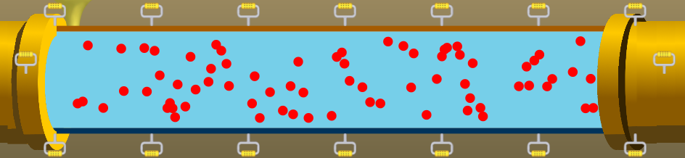

In the current simulation, the volume flow rate is 5000 L/s, or 5 m³/s. This means that 5 cubic meters of water are passing through the pipe in a second. If the density of this water is 1000 kg/m³, answer the following questions.

- What is the volume of water that flows through the pipe in 6 seconds?

- What is the mass flow rate of the water?

- What is the mass of the water that flows through the pipe in 6 seconds?

Part VI: Continuity

- The mass flow rate and the volume flow rate are always the same in a closed pipe. Why do you think that has to be the case? (Try and think about what might happen if the rates were not the same). ________________________________________________________________________________________________________________________________________________________________________________________________________________________________________________________________________________________________________________________________________________

Setup
- Select the ‘Flux meter’ option
- Drag the pipe so that you have areas of 12.5 m², 10.0 m², 5.0 m², 2.5 m², and 1.0 m²

- What do you notice about the volume flow rate at different points along the pipe? ________________________________________________________________________________________________________________________________________________________________________
- What do you notice about the speed of the water at different points along the pipe? When is the water the fastest? The slowest? ____________________________________________________________________________________________________________________________________________________________________________________________________________________________________________________________

- Use the simulation to fill in the table below.
Area  (m²) | Speed  (m/s) | Volume Flow Rate  (m³/s)
1.0
2.5
5.0
10.0
12.5

- Determine the continuity formula, which relates two points where fluid flows in a closed pipe.

Answer the questions below about water moving through a closed pipe.

- Determine the speed at which water would flow through a point in the pipe that has a cross sectional area of 0.25 m² and a volume flow rate of 5.0 m³/s.

- Determine the speed at which water would flow through a point in the pipe that has a cross sectional area of 0.25 m² and a volume flow rate of 10.0 m³/s.

- Determine the speed at which water would flow through a point in the pipe that has a cross sectional area of 1.0 m² and a volume flow rate of 10.0 m³/s.

- Determine the speed at which water would flow through a point in the pipe that has a cross sectional area of 1.0 m² and a volume flow rate of 20.0 m³/s.

