Physics Lab 10154
Lab #2 – Acceleration Due to Gravity
TCU Department of Physics and Astronomy

Name: ID#:
All simulations and online material are provided by University of Colorado Boulder https://phet.colorado.edu/en/simulations/category/physics
Learning Goals: Students will be able to
- Study the nature of uniformly accelerated motion by observing the position versus time of a uniformly accelerated object Use reasoning to explain the predictions.

- The study of the motion of an object on the ramp will be used to accomplish the determination of an experimental value for the acceleration due to gravity (g)

Theoretical Background:
When an object undergoes one dimensional uniformly accelerated motion, its velocity increases linearly with time. If it is assumed that the initial velocity of the object is zero at time t=0, then its velocity at any later time (t) is given by v =a t where a is the acceleration which is assumed to be constant in magnitude and direction . Consider a time interval between t = 0 and any later time (t). then, the displacement (X) of the object during the time interval (t) is given by:

$$x=\overline{v}t=\frac{vt}{2}=\frac{\left(at\right)t}{2}=\frac{1}{2}at^{2}$$

Thus, this latest equation states that if an object is released from rest, its displacement is directly proportional to the square of the elapsed time. Now, consider a glider that is placed on an air track as shown below in the figure. It is raised at one end to form an inclined plane with an angle θ.

The object moves down the ramp with acceleration (a) that is simply a component of gravity (g). The acceleration due to gravity points directly downwards but it can be resolved into two components that are perpendicular and parallel to the ramp. The component parallel to the ramp is equal to the acceleration (a) and is given by a = g sin θ.
g
d
y

To satisfy the objectives do the following steps.
Open the following link to collect your data.
https://phet.colorado.edu/en/simulation/legacy/the-ramp

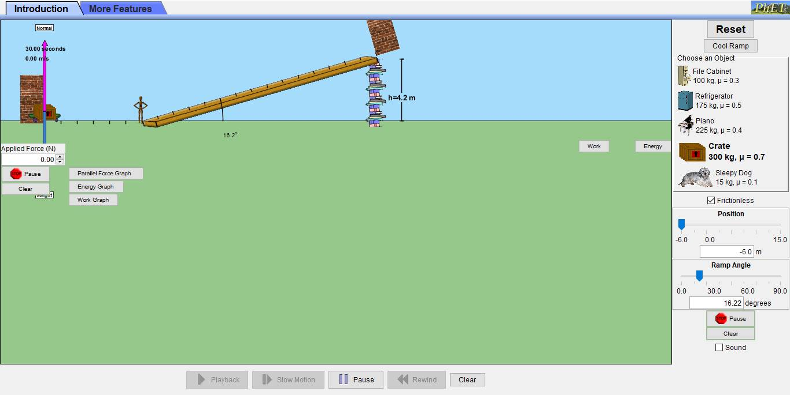

- Control the height (y) of the ramp and record it in table below. Keep this constant.
- Control angle (θ) between the ramp and the horizontal level and record it in table below.
- Control the distance that will be travelled along the ramp by the object using the position controller.
- Once you have fixed (X), check on frictionless check square to allow the object to slide down the ramp from zero initial velocity.
- Once at the end of the ramp, press stop before hitting the wall and read the velocity from the velocity meter displayed on the sim window (top left).
- Record the velocity in the table below.
- Calculate the time needed for the sliding object to travel the distance x along the ramp using the following equation:
$$X=(\frac{v_{o}+v_{f}}{2})t$$
- Repeat steps 3 to 7 and fill your data in the table below.

Data Tables:

Y (m) =
θ (degrees) =
X (m) | V (m/sec) | t (sec) | t² (sec)²
15
13
11
9
7
5

Data Analysis:

1- Use excel software/or whatever you prefer to draw a graph of X vs t² (Attach the graph to your activity)
2- Perform a linear best fit to the data of X versus t².
3- The slope of this fit should be equal to (a/2) where a is the glider’s acceleration.
4- Calculate the gravity g where
$$g=\frac{a}{sinθ}$$

Slope =
a_{exp.} =
g_{exp.} =

Questions:
- If instead of X vs t², you drew the relationship between X and t, what is the expected shape of the graph? Why is this? Please explain using equations if necessary.

- Compare and contrast your results with what you would obtain for a mass moving at a constant velocity (zero acceleration). Explicitly state how your X vs t graph would differ for these two cases.

- How would your results change if you used a much smaller mass? Would you obtain a larger, smaller, or identical value of g from the data?

