**Physics Lab 10154**

**Lab #3 – Projectiles**

**TCU Department of Physics and Astronomy**

**Name: ID#:**

All simulations and online material are provided by University of Colorado Boulder <https://phet.colorado.edu/en/simulations/category/physics>

**Learning Goals:** Students will be able to

* Predict how varying initial conditions effect a projectile path *(various objects, angles, initial speed*, *mass, diameter, initial height, with and without air resistance)*
* Use reasoning to explain the predictions.
* Explain common projectile motion terms in their own words. (*launch angle, initial speed*, *initial height, range, final height, time)*
* Describe why using the simulation is a good method for studying projectiles.

**Theoretical Background:**

The details of a projectile's trajectory depend on its launch angle and initial speed. The horizontal distance from launch to landing is called the RANGE R. The initial height H of the projectile will help to determine the final range along with the angle and speed of the launch. We must relate this initial height and the initial speed and angle to the flight range according to simple kinematic mechanics.

Horizontal Launch:

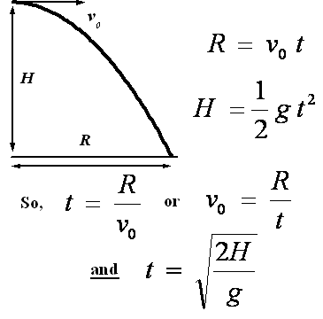For a ball launched horizontally off a table the vertical and horizontal displacement can be related in the following way:

where R is the horizontal displacement, H is the vertical

displacement, and t is the flight duration. Note that in this

instance the ball is initially dropping from rest in the vertical

direction, while it is moving at a constant speed in the

horizontal direction throughout its flight. These statements

result in the form of the equations for R and H

given above (valid for a horizontal launch). Consequently,

from a measurement of R and H (and knowledge of the

acceleration due to gravity g), it is possible to determine the

horizontal velocity (which corresponds to the muzzle velocity

for the ball when it is launched horizontally).

Launch at an Angle:

To relate the range R of a ball launched at an angle (measured from the horizontal axis), we start by describing the vertical motion. In this case, the ball is launched so it initially has an upward component of velocity such that its vertical displacement is initially upward and then later downward. By defining "down" as positive we obtain the following simple expressions for the vertical and horizontal motions:

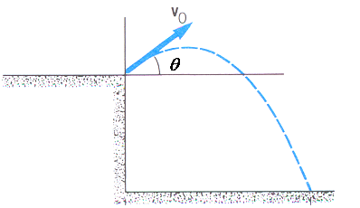



where, once again, H is the final vertical displacement and R is the horizontal displacement and we (again) realize that the horizontal motion is determined by the unchanging horizontal velocity component, as shown above. If we do not know the initial speed but can measure H and R, we should be able to analyze the situation. For example, let us use the above equations to find an expression for the initial speed in terms of H and R, as follows:



Again, the initial speed obtained above gives us our estimate of the muzzle velocity: the speed of the ball as it leaves the launcher at some specific angle.

Note: using the above formula for the muzzle velocity for a launch angle of zero you obtain an identical formula as that could be obtained in the previous section for a horizontal launch (**).

**Procedure:**

Click on the link: <https://phet.colorado.edu/sims/html/projectile-motion/latest/projectile-motion_en.html> and select the rightmost option (Lab).

Horizontal Launch

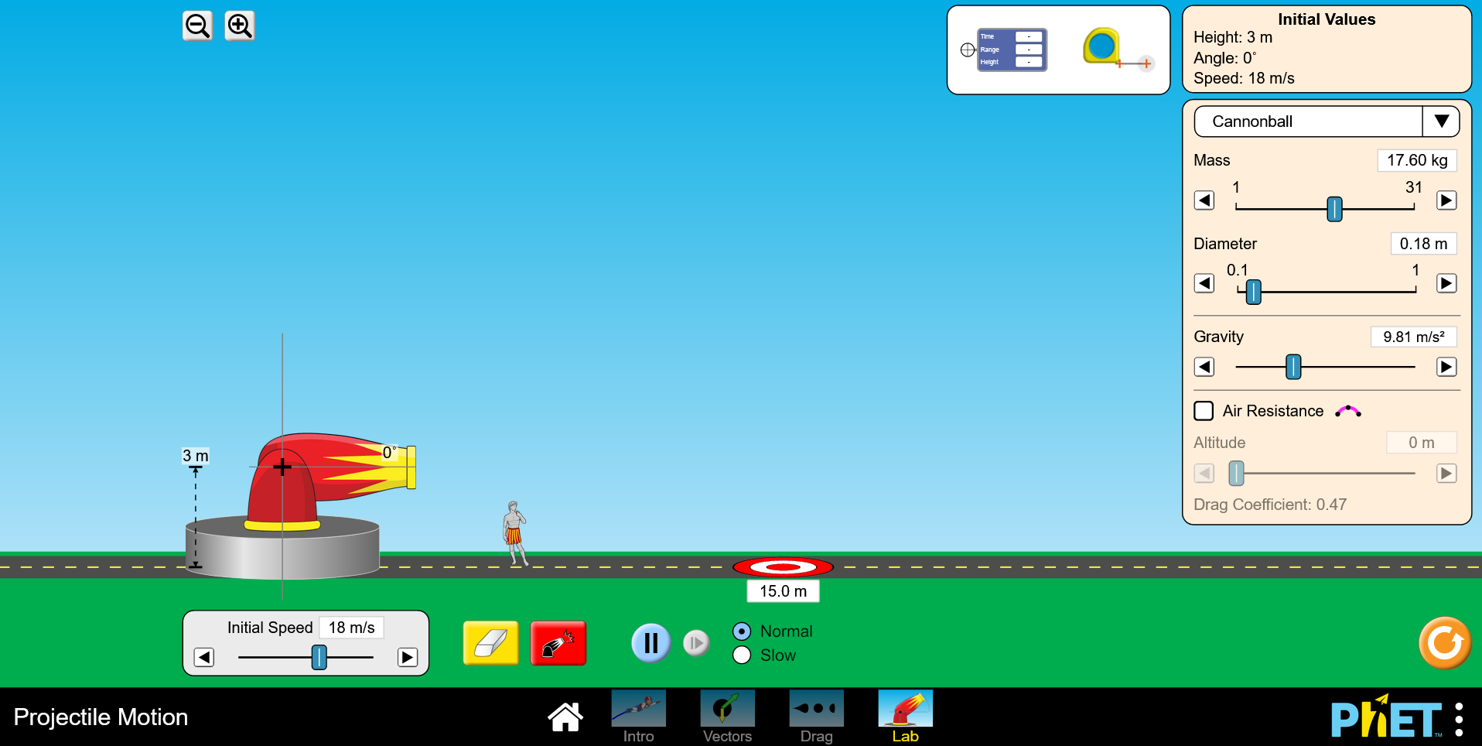

1. Adjust the cannon so that it is horizontal to the ground. Make sure in the right-hand panel that mass, diameter, and gravity remain the same. Also, make sure the Air Resistance box is unchecked. Run 5 trials where you change the height of the cannon and calculate the time of flight and the cannonballs range. Record these calculations in the table below. Check these answers using the target tool in the top toolbar. (Provide at least one set of calculations for both the time of flight and range in this report)

|  |  |  |  |
| --- | --- | --- | --- |
| **Trial** | **Height (m)** | **Time of flight (s)** | **Range (m)** |
| 1 |  |  |  |
| 2 |  |  |  |
| 3 |  |  |  |
| 4 |  |  |  |
| 5 |  |  |  |

1. Place the cannon at 9 meters high. At what velocity must the cannonball be fire to hit the bullseye at 15 meters away? (Provide this calculation)

Angled Launch

1. Play around with launch angles to see how it affects the range of the projectile.
   1. For each of the launch angles in the table below, launch a projectile from a height of 9 meters and measure the projectile range using the target tool in the toolbox at the top. Are these ranges expected?

|  |  |  |
| --- | --- | --- |
| **Trial** | **Launching Angle** | **Experimental Value of Range (m).** |
| 1 | 150 |  |
| 2 | 250 |  |
| 3 | 350 |  |
| 4 | 450 |  |
| 5 | 550 |  |

1. Choose an angle between zero and 60 degree at 9 meters high:
   1. Using the equation from this manual for angled launches, calculate and record the velocity necessary to hit the bullseye in the table below.
   2. Record the time of flight in the table below.
   3. Repeat this for a different angle to fill in the rest of the table below.

|  |  |  |  |  |
| --- | --- | --- | --- | --- |
| **Trial** | **Angle (degrees)** | **Range (m)** | **Time of flight (s)** | **Velocity (m/s)** |
| 1 |  | 15 |  |  |
| 2 |  | 15 |  |  |
| 3 |  | 15 |  |  |
| 4 |  | 15 |  |  |
| 5 |  | 15 |  |  |

**Questions:**

1. Using the equations for a horizontal launch, derive an equation that describes the velocity of a projectile as a function of R, H, and g. This will require some algebra (see the Theory Description section). (HANDWRITTEN derivation)
2. Using the equation describing the velocity for an angled launch (final equation), prove that when the launcher is horizontal (at an angle of zero with respect to the ground) the equation is equal to the velocity equation for a horizontal launch. (HANDWRITTEN derivation)