Physics Lab 10154
Lab #5 – Friction
TCU Department of Physics and Astronomy

Name: ID#:
All simulations and online material are provided by University of Colorado Boulder https://phet.colorado.edu/en/simulations/category/physics
Learning Goals: Students will be able to
- Explore the force of friction and how it interacts when different objects are in contact with one another.
- Change the amount of force applied to a specific object to observe the net force required to make this object move.
- Have a clear understanding of the function the force of friction plays when two objects are in contact with one another. Students will be able to identify what friction is and how it resists the movement of objects.

Procedure:
In this activity, we will explore the force of friction and observe how friction resists the movement of objects in motion. To access the simulation, follow the following steps:
- Go to phet.colorado.edu in your search browser
- In the search bar (top right corner of the webpage), type in “forces and motion: basics”
- Open the sim.
- Click the third box, labeled “friction.”
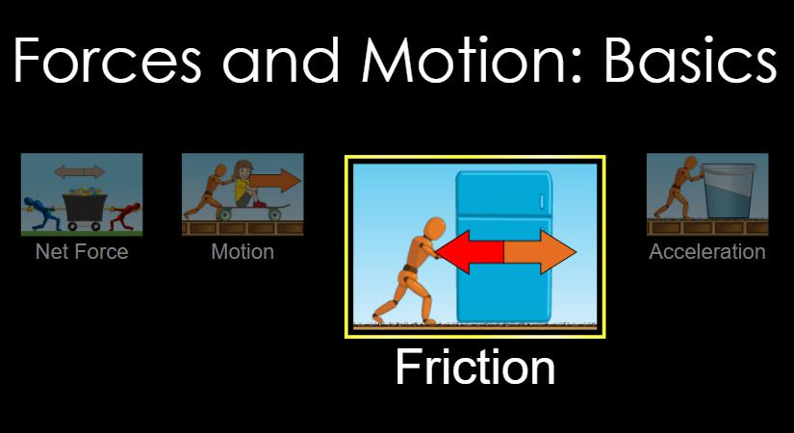

Your computer screen should now look like this. Take a minute to examine the different parts of the simulation before you explore.

STEP 5: In the top left corner, check the following boxes:
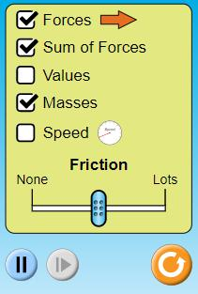
- forces
- sum of forces
- masses

EXPLORE
- Apply a force of 100 Newtons to the 50kg box. To do this, click the double fast forward button on the bottom of your screen twice.
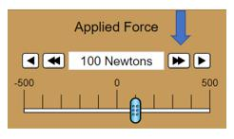

Record what, if anything, happens to the motion of the block above.
_____________________________________________________________________________________

_____________________________________________________________________________________
_____________________________________________________________________________________

- Now apply a force of 100 Newtons to the same 50kg box. Using the chart as a guide, apply the various forces to the 50kg box, and record your results on the next sheet.

Force | Result
100N
150N
200N
250N
If the 50kg box does move at any point during this force application process, when? What happens to the block as you increase the force applied to it?
_____________________________________________________________________________________
_____________________________________________________________________________________

_____________________________________________________________________________________

- Reset the sim and click the speed option in the top left. Reapply a force of 150 Newtons to the 50kg box. Wait and watch the screen for 30 seconds. Record what happens to the speed of movement as time passes.

_____________________________________________________________________________________
_____________________________________________________________________________________
_____________________________________________________________________________________

EXPLAIN:
- Lessen the applied force of the 50 kg box from 150 Newtons, first to 100 Newtons and then to 50 Newtons. Why do you think the box continued to move as you lessoned the amount of force applied to it now, when it did not initially move when 50N and 100N respectively were initially applied to the block?

_____________________________________________________________________________________
_____________________________________________________________________________________
_____________________________________________________________________________________
- Reset the sim. Now check the following boxes:
  - forces
  - sum of forces
  - masses
  - speed

Set the friction bar to none.
Apply a force of 10 Newtons on the 50 kg box. Record your observations in the below chart, changing the amount of force applied to the box as described. Reset the sim between each attempt.

Force | Result
100N
150N
200N
Your choice:

Why do you think the box was able to move quickly and with ease when friction was removed from the equation? What does this observation tell you about the force of friction in terms of moving objects?
_____________________________________________________________________________________

_____________________________________________________________________________________
_____________________________________________________________________________________

CHALLENGE:
- Reset the sim. Now check the following boxes:
  - forces
  - sum of forces
  - masses
  - speed

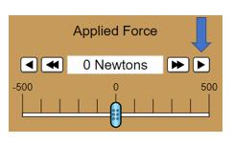
What is the minimum amount of force needed to move the 50 kg box? Why? Hint: To answer this question, you will need to click the single fast forward button on the “applied force” bar.

_____________________________________________________________________________________
_____________________________________________________________________________________
_____________________________________________________________________________________

- Reset the sim. Now check the following boxes:
  - forces
  - sum of forces
  - masses
  - speed

Remove the 50 kg box and replace it with the 80 kg man. What is the minimum amount of force needed to move the man? How are you able to tell?

_____________________________________________________________________________________
_____________________________________________________________________________________
_____________________________________________________________________________________

EXIT TICKET

- After exploring this simulation, what can you deduce about the force of friction? What is friction responsible for? How are you able to come to this conclusion?

_____________________________________________________________________________________
_____________________________________________________________________________________
_____________________________________________________________________________________

2. Would it be easier for you to rollerblade on grass or on concrete? Explain your answer.

_____________________________________________________________________________________
_____________________________________________________________________________________
_____________________________________________________________________________________

3. Why is it easier for you to slide on a carpet when wearing socks, as opposed to sneakers?

_____________________________________________________________________________________
_____________________________________________________________________________________

_____________________________________________________________________________________

