Physics Lab 10154
Lab #6 – Conservation of Energy
TCU Department of Physics and Astronomy

Name: ID#:
All simulations and online material are provided by University of Colorado Boulder https://phet.colorado.edu/en/simulations/category/physics
Definitions:
- Kinetic Energy (KE, E_{k}) – The energy of a moving mass. No motion, no kinetic. Dependent on speed.
- Potential Energy due to gravity (PE_{g}, E_{g,} PE_{grav}) - The potential to move based on height. More height, more potential energy. No height, no potential gravitational energy.
- Elastic potential energy (E_{el}, E_{elas}) – The potential to move due to the stretch or compression of a spring or rubber band. No elastic object, no E_{el}.
- Thermal (internal) energy (E_{Therm} , E_{heat}, E_{int}) – The energy friction ‘steals’ and turns into heat or internalized thermal energy. This energy is not able to return to potential or kinetic in our models. Requires friction to occur.
- Work – A force parallel to the displacement of an object’s motion will do work on an object and will add or remove energy. Work occurs when energy is added or removed from an object or system by an outside agent. Work is the only thing that can change total energy in these models today.

Theoretical Background:
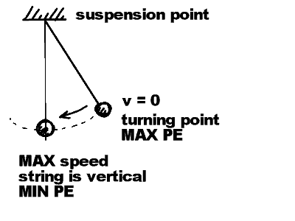
A simple pendulum is a mass that swings from a long string, suspended from above. As a pendulum mass swings back and forth it repeats the same motion over and over. For example, we will consider a pendulum that originally is at rest with its string supporting the mass and making a non-zero angle with the vertical axis. Once the mass is released it moves away in a circular arc and then moves back to its starting point along the same path. This back and forth motion is ONE OSCILLATION of the pendulum. The time it takes for one oscillation is the PERIOD of the pendulum. At the bottom of the pendulum's trajectory, it is moving at its fastest. At the two turning points of its trajectory the pendulum's speed is zero and its height above the table (or floor) is at a maximum. At the turning points the pendulum has no kinetic energy (KE) and at the bottom of the trajectory. The pendulum mass has its minimum gravitational potential energy (PE) and its maximum kinetic energy. If no energy is lost from the moving pendulum, the sum of its kinetic and potential energies (the total mechanical energy TE) remains a constant. Its exact value depends on how massive it is and how high it was when it was released. If energy is lost from the moving pendulum (due to frictional forces on the mass and the string) we can determine the average rate that mechanical energy is lost. A measurement of this "Average Frictional Power" is obtained by measuring the time it takes for the pendulum to lose a measured fraction of its initial total energy. If this energy loss rate is small, then mechanical total energy (TE) will change very little during a single oscillation.
Procedure:
- Go to the following link and select the Energy option: https://phet.colorado.edu/en/simulation/pendulum-lab
- Click and drag the pendulum to about 35 degrees to start the motion. You may press the SLOW button in the bottom if it makes it easier to view.
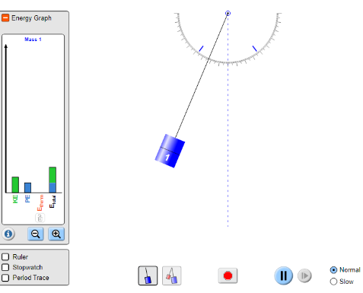
Watch the energy bars as the pendulum swings.

- Explain (in words or with a drawing) what you see happening with the kinetic and potential energy:

- When the pendulum is all the way to one side, slide gravity to maximum. Describe what happens to the pendulum and its energies.

- When the pendulum is furthest up what is its only energy?

- When the pendulum is at its low point, what is its only energy?

- Does the total energy ever change?

- Put FRICTION to max. What energy now shows up and what happens to the pendulum?
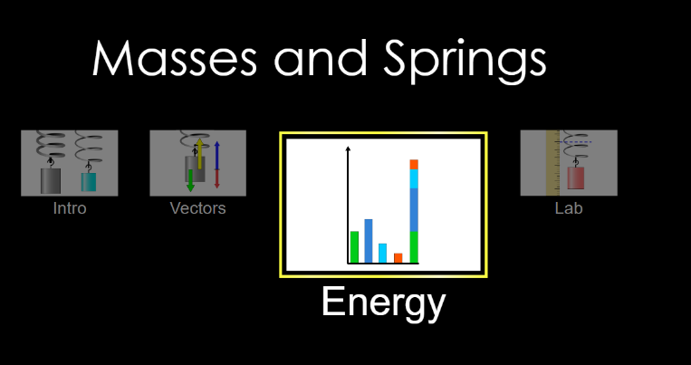
Go to the following link and again select Energy: https://phet.colorado.edu/sims/html/masses-and-springs/latest/masses-and-springs_en.html
- Set MASS to maximum (300 g)
- Set DAMPING (friction) to ZERO
- Hit SLOW on the bottom if it helps.
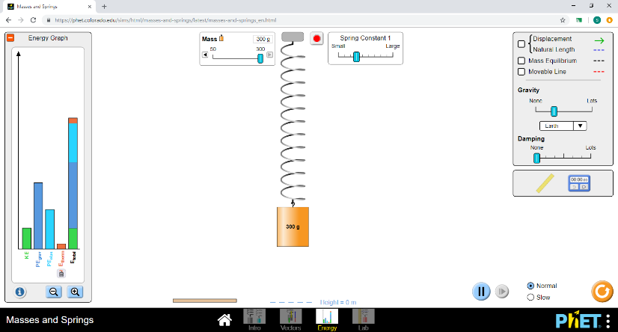
We will be working with the following energies.
Kinetic (KE) - energy while MOVING
Potential from gravity (PE_{grav}) – energy with HEIGHT
Elastic potential (PE_{elas}) – Energy due to SPRING/band
Thermal (E_{therm}) – Energy lost to FRICTION (heat, internal)
Questions (circle/highlight/underline the following answers):
- Where is KE (kinetic) the highest:
Bottom Middle TOP
- Where is PE_{grav} (potential from gravity) the highest:
Bottom Middle TOP
- Where is PE_{elas} (elastic) the highest:
Bottom Middle TOP
- Does the total ever change?
YES NO

- Draw all the energies at the following points:
E_{k} E_{g} E_{elas} E_{int} E_{total}
E_{k} E_{g} E_{int} E_{total}
E_{k} E_{g} E_{elas} E_{int} E_{total}
E_{k} E_{g} E_{int} E_{total}
E_{k} E_{g} E_{elas} E_{int} E_{total}

z

at the top halfway down at the bottom
- When the spring gets to the top, Make the mass HALF as big. What happens to all your energies?

- Put damping (friction) on. What changes in your energy bars and what eventually happens to the mass and spring?

- Think of the forces acting on the mass. What is the force pulling the mass and thus the spring down to stretch it?

